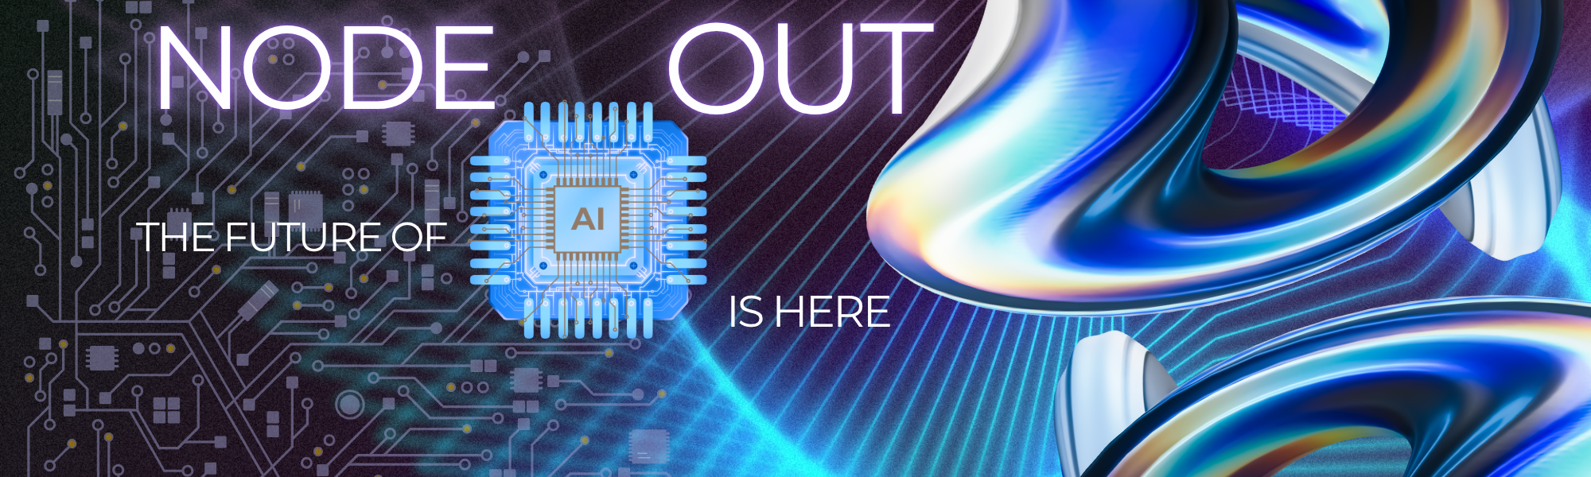

The Future is Automated. Are You Ready?

**Welcome to NODE OUT - Where NO DOUBT Lives.**

Robots aren't coming—they're here, and they brought the party!

While everyone's busy asking "what's next in AI?" we're asking the only question that matters: **How will YOU use it?**

Here's the thing—everyone's selling packaged AI solutions like they're frozen dinners. Pre-made. One-size-fits-all. Boring.

But you? You're not everyone.

**Enter NODE OUT.** We built CLAY-I, Observer Node, and Content Alchemist not as rigid tools, but as your creative playground. One voice note becomes a week of content. One idea transforms into an ecosystem. One moment of inspiration multiplies into a movement.

The best part? When you're using it right, there's NO DOUBT. You feel it. Your audience feels it. The results speak louder than any pitch deck.

The tech wave is here, and the adaptable are already surfing. The question isn't whether you'll ride it—it's whether you'll carve your own path or follow someone else's wake.

Your move, creator. Let's make waves together.

Ready to dive in? Let's show you what happens when YOUR ideas meet OUR amplification engine.

**When there is NO DOUBT its your moment. We leave NODE OUT as your tool.**

|  |
| --- |
| Meet Your AI-Powered Arsenal |

|  |  |
| --- | --- |
| Clay-I:  ***Your Personal Intelligence Core***   * *Your AI brain.* * *Learns your patterns.* * *Predicts your needs.* * *Understands all the data.* | Clay-I is more than just an AI assistant; it's your personal intelligence core. It learns your habits, anticipates your needs, and connects the dots across all your data sources. Imagine having an AI that understands your workflow as well as you do, proactively suggesting solutions and automating tasks before you even think of them. Clay-I makes that a reality. Unlock your full potential. |

|  |  |
| --- | --- |
| ObserverNode**:**  **The Ultimate Content Router**   * Filters out the noise. * Delivers relevant information. * Customizable alerts. * Keeps you informed, always. | Drowning in information? ObserverNode acts as your intelligent content router, filtering out the noise and delivering only the most relevant information directly to you. Set custom alerts based on your specific interests and never miss a critical update again. Stop wasting time sifting through endless feeds and start focusing on what truly matters. |

|  |  |
| --- | --- |
| Content Alchemist:  **Expand Your Reach**   * Repurpose existing content. * Generate fresh ideas. * Reach wider audience. * Maximizes your output. | Don't let your content gather dust. Content Alchemist empowers you to repurpose existing material and generate fresh ideas, maximizing your output and expanding your reach. Turn one blog post into a series of social media updates, or transform a webinar into a compelling infographic. Unlock the hidden potential within your existing content library and reach a wider audience with minimal effort. |

|  |
| --- |
| Unleash the Power of Automation with n8n |

NODE_OUT seamlessly integrates with n8n, the powerful open-source workflow automation platform. This integration allows you to create sophisticated automation pipelines that connect all your favorite tools and services. Imagine automating your entire content creation process, from research to publishing, with just a few clicks. With n8n and NODE_OUT, the possibilities are endless. Automate repetitive tasks, free up your time, and focus on what you do best.

**Stop Reacting, Start Innovating**

The digital landscape is constantly evolving, and those who react slowly are doomed to be left behind. NODE_OUT provides you with the tools you need to stay ahead of the curve, anticipate future trends, and innovate faster than ever before. Don't just survive – thrive.

|  |
| --- |
| Next Steps |

Ready to revolutionize your workflow and unlock your full potential?

* **Schedule a Demo:** See NODE_OUT and Clay-I in action.
* **Start a Free Trial:** Experience the power of automation firsthand.
* **Contact Us:** Discuss your specific needs and how NODE_OUT can help you achieve your goals.

The future is here. Embrace it with NODE_OUT.